**Default Klovnene's guide to "the insane"**

Klovnene's guide to "The Insane"

SOME OF THE PROFILES ARE OUT OF DATE, THEY WILL BE UPDATED AFTER THIS SUMMER  
  
This is for the "Feat of Strength" Insane in the membrane, wich will grant you the title: "The Insane"  
NB: You will need a rogue for this, if u dont have that, u cant finish this FoS  
http://i1137.photobucket.com/albums/n520/Uran90/Bloodsail.jpg  
For this rep, i am not going to make a profile, because the only way to get this rep is farming guards in Booty Bay, to do that,, open your rep tap (U) and find Booty Bay, and set "At war" then just kill as many as possible. Farm that to Honored. A profile for Faldir's cove is comming up as soon as im a little less lazy :P  
  
http://i1137.photobucket.com/albums/n520/Uran90/SteemwheedleCartel.jpg  
This place is the shit.. After having farmed the Pirate rep to honored, you now need to farm theese to EXALTED without loosing any rep at the pirates. In old days it was easy, just going Dire Maul. Now its harder. You have to grind mobs. Ive already made 1 profile farming in tanaris. It will Kill wastewanders. LVL 45-48 mobs. Easy to kill, but from 0 in Hated to exalted will take almost forever.   
Getting around 300 kills in 1 hour here. But getting between 2-5 rep per mob. Obviously no vendor or mailing, cus u are hated at gadgetzan :P  
After beeing at this place, just realised that that i was stuck on 5999/6000 rep friendly, at gadget. So use Steamwheedle Cartel 2, wich give around 600 kills per hour, to 11999/12000 honored and after honored go to fray island. wich will go all the way to exalted with gadget. After that, go back to steamwheedle cartel 2.  
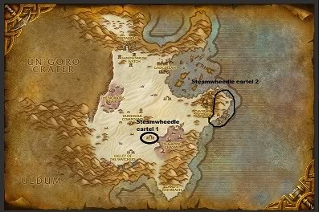 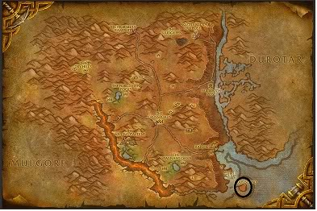  
  
http://i1137.photobucket.com/albums/n520/Uran90/Ravenholdt.jpg  
Horde and Alliance characters of all classes start at 0/3000 Neutral with Ravenholdt!  
For this rep, you will need a good rogue friend, or lvl one your self. You can kill syndicates, and decrease your rep with syndicates with 25, but increase rep with Ravenholdt by 5. This can only be done till 11999/12000 Honored. 5 rep per kill, so 4200 kills. Easy. But then you will need the Heavy Junkboxes repeatable quests, wich can be Pick-pocketed by rogues. And you will need estimated 1405 boxes   
Northfold Manor is for killing, Dreadwind-altar is pick-pocketing in Blasted Lands  
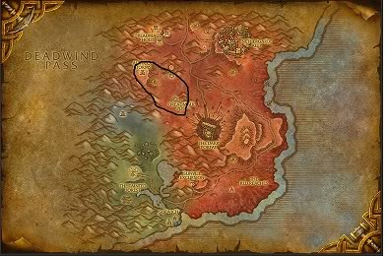 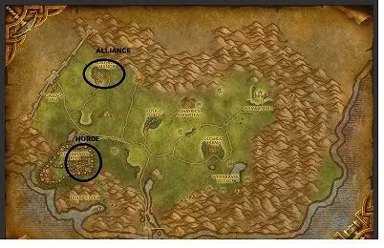  
  
  
http://i1137.photobucket.com/albums/n520/Uran90/DarkmoonFaire.jpg  
The hardest one, is always the last one, and in this case, its the same.  
This rep sucks ***   
You need to do repeatable quest and turn in Darkmoon Faire Tickets. U can do that from Neutral to 2000/6000 Friendly (stupid point) Everythin after that is either turning in epic Decks or Inscriptor green decks. Green decks will give you 25 rep, epic decks 350 rep. And this will be expensive, i suggest buying the 60 epic decks from ah, when they are cheap. 60 decks still will grant 350 rep. So just stalk AH for that.  
So now u got the decks. Where do i use it? Well if u only have epic decks do this: Darkmoon Faire is open from the first sunday in the month and is in 3 different places all over the world.  
I wish i could show all three pics, but the limit for pics is 10, and i have 11 :P but here are two pictures:  
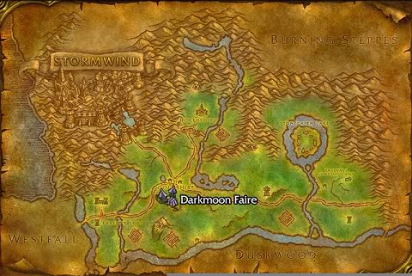 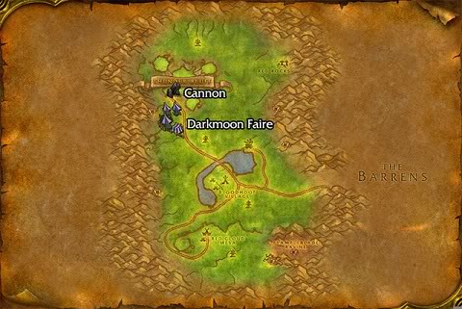   
  
And then u need to find the Darkmoon card guy. How u do that: Click on one of the cards, and accept quest. Walk to the guy and Deliver.   
OR  
Use Sainter222's guide for this [http://www.thebuddyforum.com/honorbu.../guides/16221-](http://www.thebuddyforum.com/honorbuddy-forum/guides/16221-)[guide]-darkmoon-faire-exalted.html  
COPY THE LINK, the name is [Guide] so that fucks up the link :P  
All credit to him for that  
  
And GZ you are now INSANE  
  
To the subject on having all rep at same time:

Quote Originally Posted by **Malice211** [View Post](http://www.thebuddyforum.com/honorbuddy-forum/submitted-profiles/farming/15305-klovnenes-guide-insane-post194212.html#post194212)

*After going over the acheivement with the 3rd GM, I was told that the acheivement does require you to have Honored rep with Bloodsail at the same time as you have exalted with the rest of the factions. Shen'dralar has been removed and is not a requirement anymore but from all the notes that he had on the acheivement you cannot trash your Bloodsail while raising rep with the goblins so the cloth turn in thing is out. Again, this is the information that they had concerning the acheivement and they believed the information to be up to date. They also apologized for any misinformation I may have received in my original ticket replies.   
  
Now as Klovnene said, it appears you get a different answer from almost every GM you discuss the situation with. I for one am going to re-grind my Bloodsail rep back to Honored for two reasons. So I can say I have it and to be certain that I will get the acheive. I am not going to take any chances. I would rather spend a few extra hours regrinding my Bloodsail back to honored than to grind everything else to exalted, not get the acheivement, and then have to do Bloodsail and loose half my exalted reps in the process. Simply not worth the risk.*

If you do not know where to move, look at the PICTURES  
  
Frequently asked questions:  
Q: How do i get my Rogue to pickpocket?  
A: This is all based on your Custom Class (CC) This is NOT controlled by me.  
  
Q: Do i need all factions at its stated rep amount at the same time?  
A: Well its hard to answer, some say yes some say no. I say. Try trashing your rep and see if u get, if u dont want to, then simply dont.  
  
More will be added later, but im tired tonight  
This post is my views on getting the insane with a bot. The info aquired is from wowhead and wowwiki. If you feel that there are missing something, post a reply and ill try to add it!  
Leave Feedback   
and if u liked it, press the STAR